SEMESTER TWO
Papers written by
Australian Maths
Software

YEAR 12, Unit 3-4

MATHEMATICS APPLICATIONS
REVISION 2
2016

Section One
(Calculator–free)

Name: _________________________________

Teacher: ________________________________

TIME ALLOWED FOR THIS SECTION

Reading time before commencing work: 5 minutes
Working time for section: 50 minutes

MATERIAL REQUIRED / RECOMMENDED FOR THIS SECTION

To be provided by the candidate
Standard items: pens, pencils, pencil sharpener, highlighter, eraser, ruler.

IMPORTANT NOTE TO CANDIDATES
No other items may be taken into the examination room. It is your responsibility to ensure
that you do not have any unauthorised notes or other items of a non–personal nature in the
examination room. If you have any unauthorised material with you, hand it to the supervisor
before reading any further.

To be provided by the supervisor

Question/answer booklet for Section One.
A formula sheet which may also be used for Section Two.
Structure of this examination

 | Number of questions available | Number of questions to be answered | Working time (minutes) | Marks available | Percentage of exam
Section One  Calculator—free | 7 | 7 | 50 | 52 | 35
Section Two  Calculator—assumed | 9 | 9 | 100 | 98 | 65
Total marks |  |  |  | 150

Instructions to candidates

1. The rules for the conduct of this examination are detailed in the Information
Handbook. Sitting this examination implies that you agree to abide by these rules.

2. Write your answers in the Question/Answer booklet.

3. You must be careful to confine your responses to the specific questions asked and to
follow any instructions that are specific to a particular question.

4. Spare pages are provided at the end of this booklet. If you need to use them, indicate
in the original answer space where the answer is continued i.e. give the page number.

5. Show all your working clearly. Your working should be in sufficient detail to allow your
answers to be checked readily and for marks to be awarded for reasoning. Incorrect
answers given without supporting reasoning cannot be allocated any marks. For any
question or part question worth more than two marks, valid working or justification is
required to receive full marks. If you repeat an answer to any question, ensure that you
cancel the answer you do not wish to have marked.

6. It is recommended that you do not use pencil, except in diagrams.

7. The Formula Sheet is not to be handed in with your Question/Answer booklet.

1. (5 marks)

Five towns are to be connected to Broadband. The distances between them are given
in the table below.

 | Towns
Towns | A | B | C | D | E
A | - | 10 | 14 | 11 | 12
B | 10 | - | 12 | 9 | 11
C | 14 | 12 | - | 7 | 13
D | 11 | 9 | 7 | - | 8
E | 12 | 11 | 13 | 8 | -

(a) Identify the minimum spanning tree using Prim’s algorithm. (3)

(b) Illustrate the minimum spanning tree on a network using the nodes below. (2)

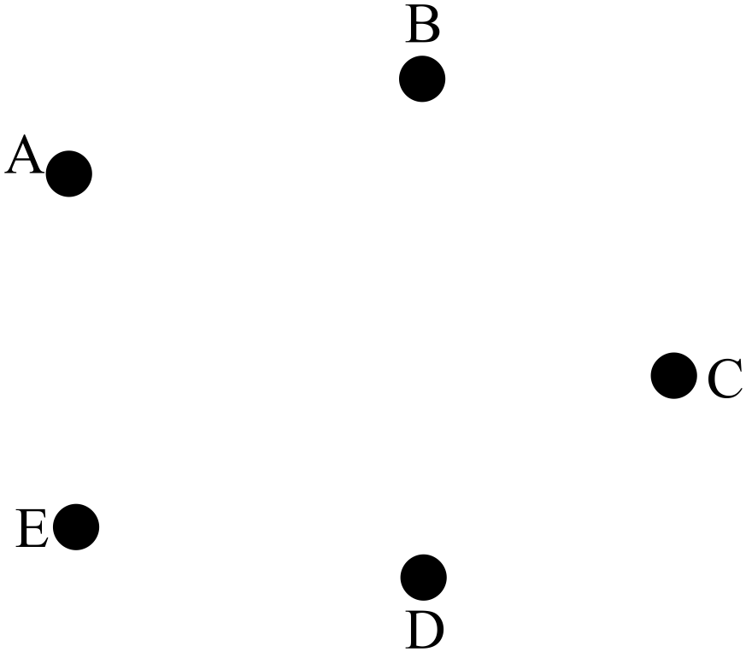
2. (11 marks)
(a) Two sequences are graphed below.
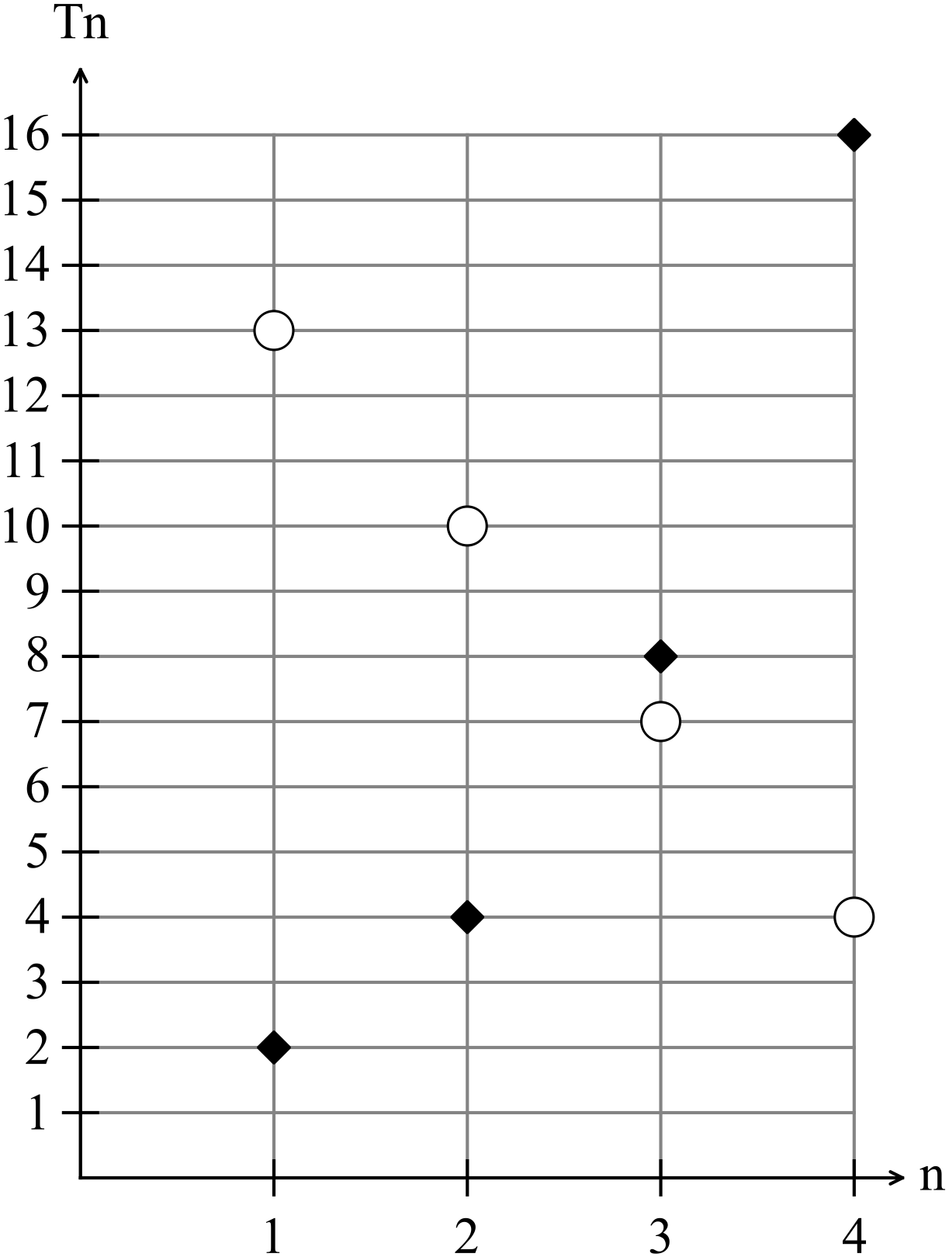
(i) Define both sequences in terms of . (4)

(ii) Define both sequences recursively. (4)
(b) Given 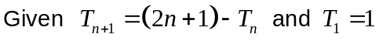 find 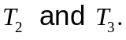 (3)

3. (4 marks)
Sketch a possible set of residuals on the given set of axes for the data below.
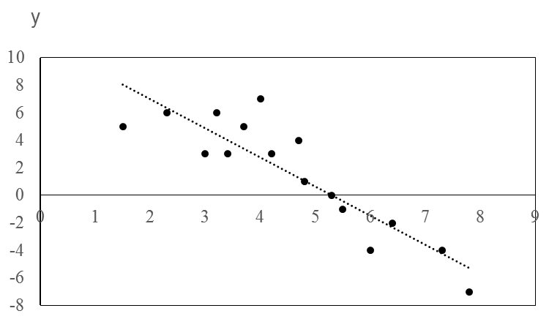
x

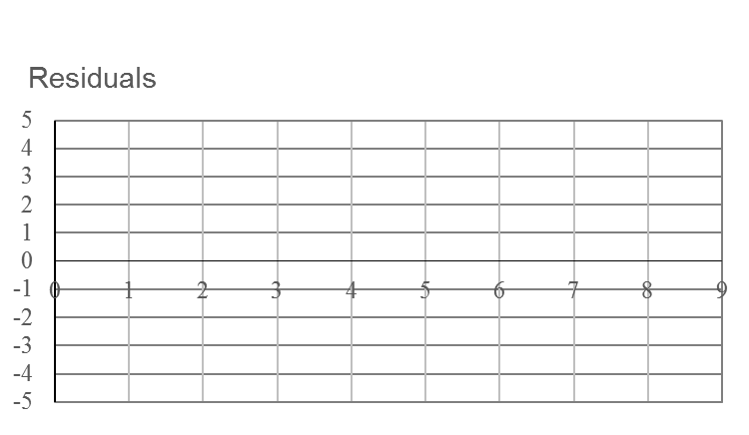

4. (7 marks)
(a) Explain what is meant by
(i) a simple graph. (2)

(ii) a closed path. (2)

(b) Shade a subset of the graph below that is a tree, has 5 arcs and 6 vertices. (3)

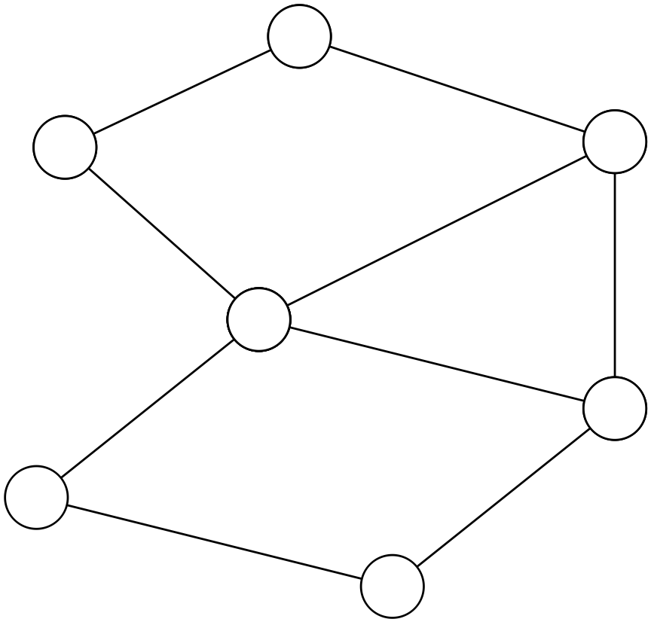

5. (6 marks)
The adjacency matrix  that illustrates the number of radio messages between ships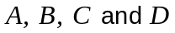.
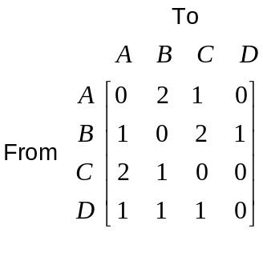
(a) Determine the number of radio messages ship receives from ships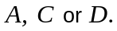
(2)

(b) Which ship receives the least number of messages? (1)

(c) Sketch the directed graph that gives the same information as the adjacency matrix using the nodes supplied below. (3)

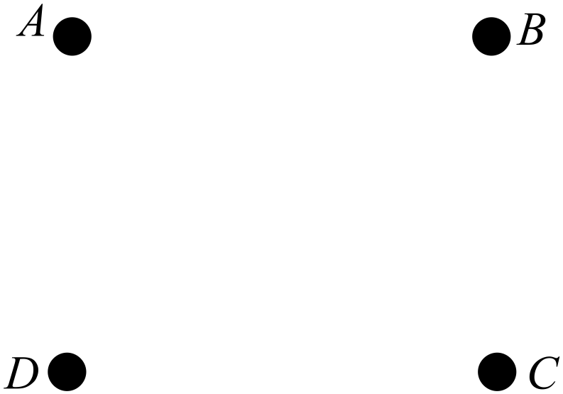
6. (7 marks)
Water is flowing through a wildlife sanctuary. Any stagnant sections need to be cleared up for the health of the animals. Stagnant sections are formed when the flow cannot all excape at any point. The flow of the water in given in litres per hour and is a trickle to attempt to help keep the enclosure clean.

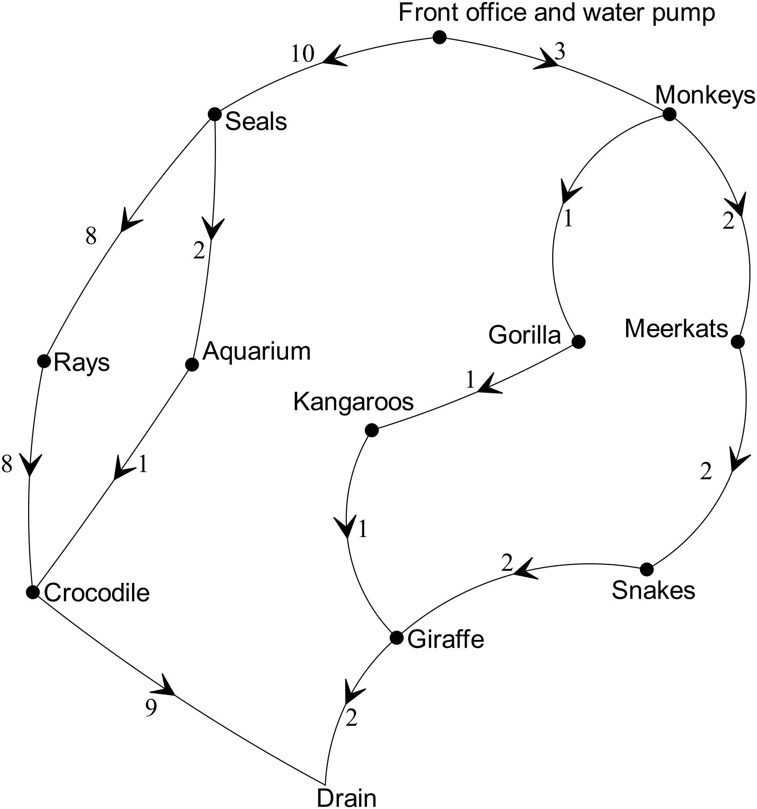

(a) Determine any sections of the wildlife section where the flow is trapped and there
may be stagnant water. (3)

(b) Which sections need to be adjusted so that 13 litres cab flow through without
being blocked and how much adjustment is needed?. (4)
7. (12 marks)

Consider the cube below.
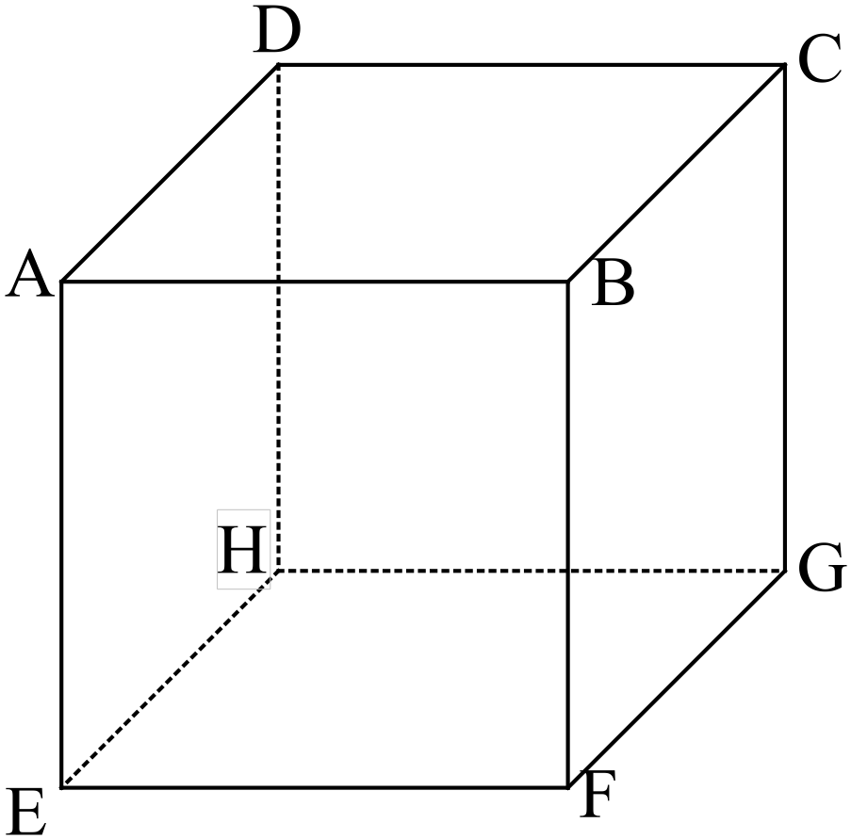

(a) (i) Write down the number of edges, faces and vertices. (2)

(ii) Show that Euler’s Rule works for the cube. (2)

(iii) Show that the cube is Hamiltonian by drawing the Hamiltonian cycle on the
cube below. (3)

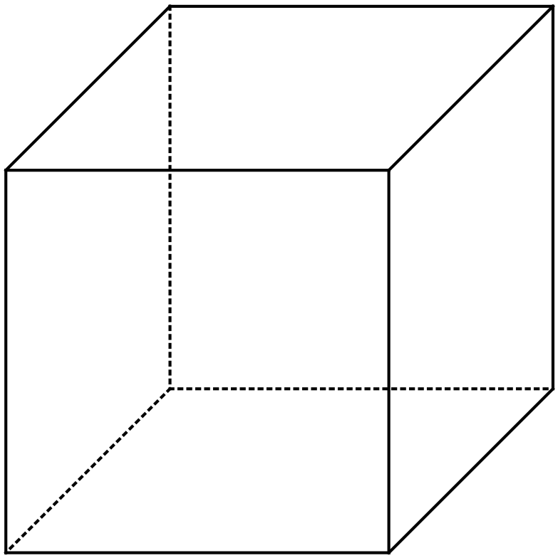

(iv) Explain why the cube is not Eulerian. (2)

(b) (i) Define a planar graph. (1)

(ii) Draw the planar graph that is equivalent to the cube. (2)

END OF SECTION ONE

